Web analytics and digital marketing
Part 8

1. Today we're finishing the project by preparing a Next JS project for the administrator and client.

2. To make things easier for you, I've attached links to Google Drive containing Front-End files for the client and administrator. You need to implement these projects into a fully functional geoportal system. Learn the operating principles yourself using the guide. And be sure to prepare a customized version for project defense. Implementing your own styles and responsive design is mandatory. If the project isn't submitted by week 15, a maximum of 30 points will be awarded. If it's completed, but with minimal changes to the version from the guide, the score will be 60 points. Therefore, the project needs to be customized.

3. Here is a link to the client front: https://drive.google.com/file/d/1M8249gqS1-6dkmnDbtK4XTAYwJ4wvFE_/view?usp=drive_link

4. Here is the link to the admin front: https://drive.google.com/file/d/1tnSovz2zHFXUtq2SchseLinpjJaEBrpY/view?usp=sharing

5. Download these projects. Let's start with the Next JS Admin Panel. Unzip this archive. Go to the project folder and run "npm install" in the terminal.

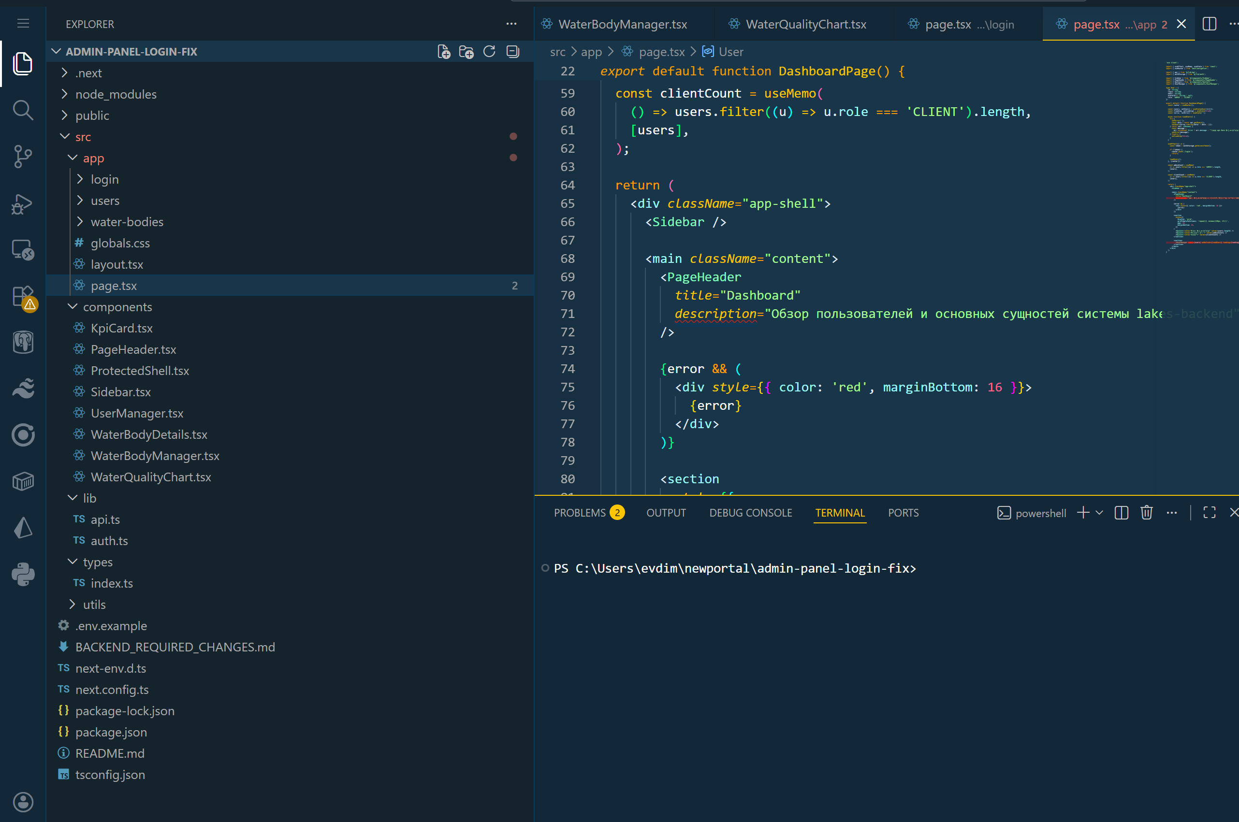

6. After installing the project, check the "package-lock.json" file. The following library versions should be installed.
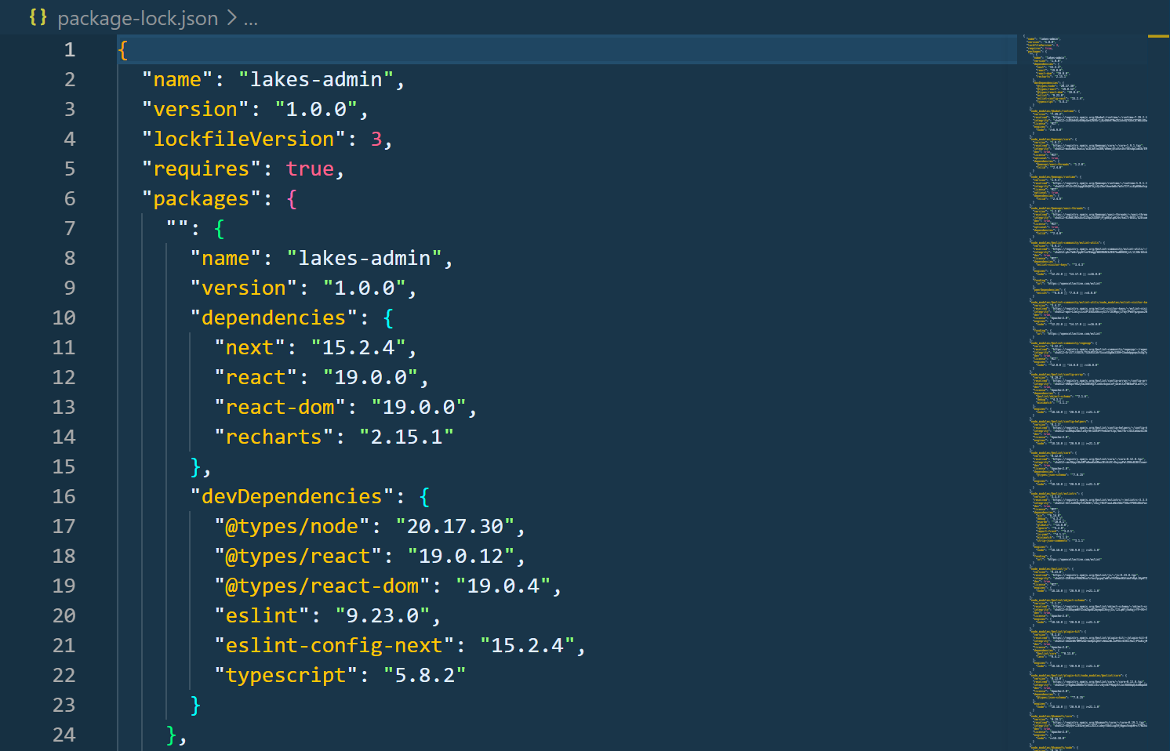

7. The current front-end project implements an administrative panel for managing a water body system. The application, developed using Next.js and TypeScript, is designed for administrators managing users, water bodies, and measurements, with analytics integrated.

8. The main layout.tsx file is responsible for the global structure of the application. It defines the HTML markup, includes global styles, and defines the overall framework for all pages. This is the base layer of the application, used in all routes.

9. The ProtectedShell.tsx component implements route protection. It checks for an access token in localStorage, and if the user is unauthorized, it automatically redirects them to the login page. This ensures secure access to the admin panel.

10. The Sidebar.tsx component implements side navigation. It contains the main sections of the system: Dashboard, Users, Water Bodies, and Logout. It is the main navigation element within the admin panel.

11. The PageHeader.tsx component is used to display page headers. It sets the title of the current section and ensures a consistent header style throughout the application.

12. The KpiCard.tsx component is used on the Dashboard page and displays key system metrics, such as the number of users, administrators, and clients. It implements the visualization of statistics in the form of cards.

13. The UserManager.tsx component is responsible for user management. It implements the following: user creation; user editing; user deletion; and displaying a list of users. It also implements a form for selecting roles (ADMIN / CLIENT) and a user table.

14. The WaterBodyManager.tsx component is responsible for managing water bodies. It allows you to: create water bodies; edit data; delete records; View a list of bodies of water. The number of measurements for each body of water is also displayed.

15. The WaterBodyDetails.tsx component implements a detailed information page for a body of water. It displays basic information (name, coordinates, region), body of water data (area, depth, biological parameters), a list of measurements, and a form for adding new measurements. This component also implements measurements. The user can add chemical and biological parameters of the water, such as pH, mineralization, salinity, hardness, and other parameters.

16. The WaterQualityChart.tsx component is responsible for visualizing measurement data. It plots graphs (LineChart or BarChart) based on selected water parameters, allowing you to analyze changes in the body of water's condition over time.

17. The lib folder contains the api.ts file, which implements interaction with the Nest JS-based backend. It describes all HTTP requests: authorization, retrieving users, creating and updating users, working with bodies of water, and working with measurements. The auth.ts file is responsible for storing tokens (access and refresh) and user data in localStorage. It implements functions for retrieving, saving, and clearing authorization data.

18. The project implements a JWT authentication system. After logging in, the user receives an access token and a refresh token. The access token is used for all requests, and the refresh token is used to refresh the session.

19. The types folder defines all the main data types, such as User, WaterBody, and Measurement. This ensures typing and simplifies development by controlling the data structure.

20. The login page implements the login form. The user enters an email address and password, which then triggers a request to the backend. Upon successful authorization, they are redirected to the admin panel.

21. The Dashboard page displays aggregated system information. It serves as the starting point for the administrator after logging in.

22. Thus, the Next JS Admin Panel project is a full-fledged administrative system that implements user authorization, user management, reservoir management, adding and viewing measurements, data visualization, and route protection. The project's architecture is modular: each functionality is separated into a separate component, making the system scalable and convenient for further development.

23. In the “lib/api.ts” file, don’t forget to include a link to your backend:

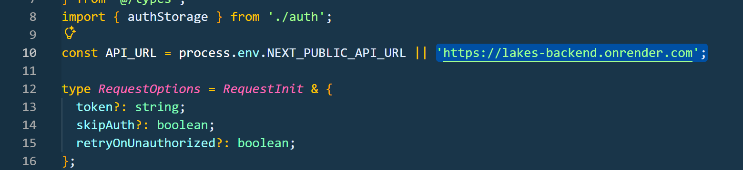

24. Sketches of the administrator panel are presented below.
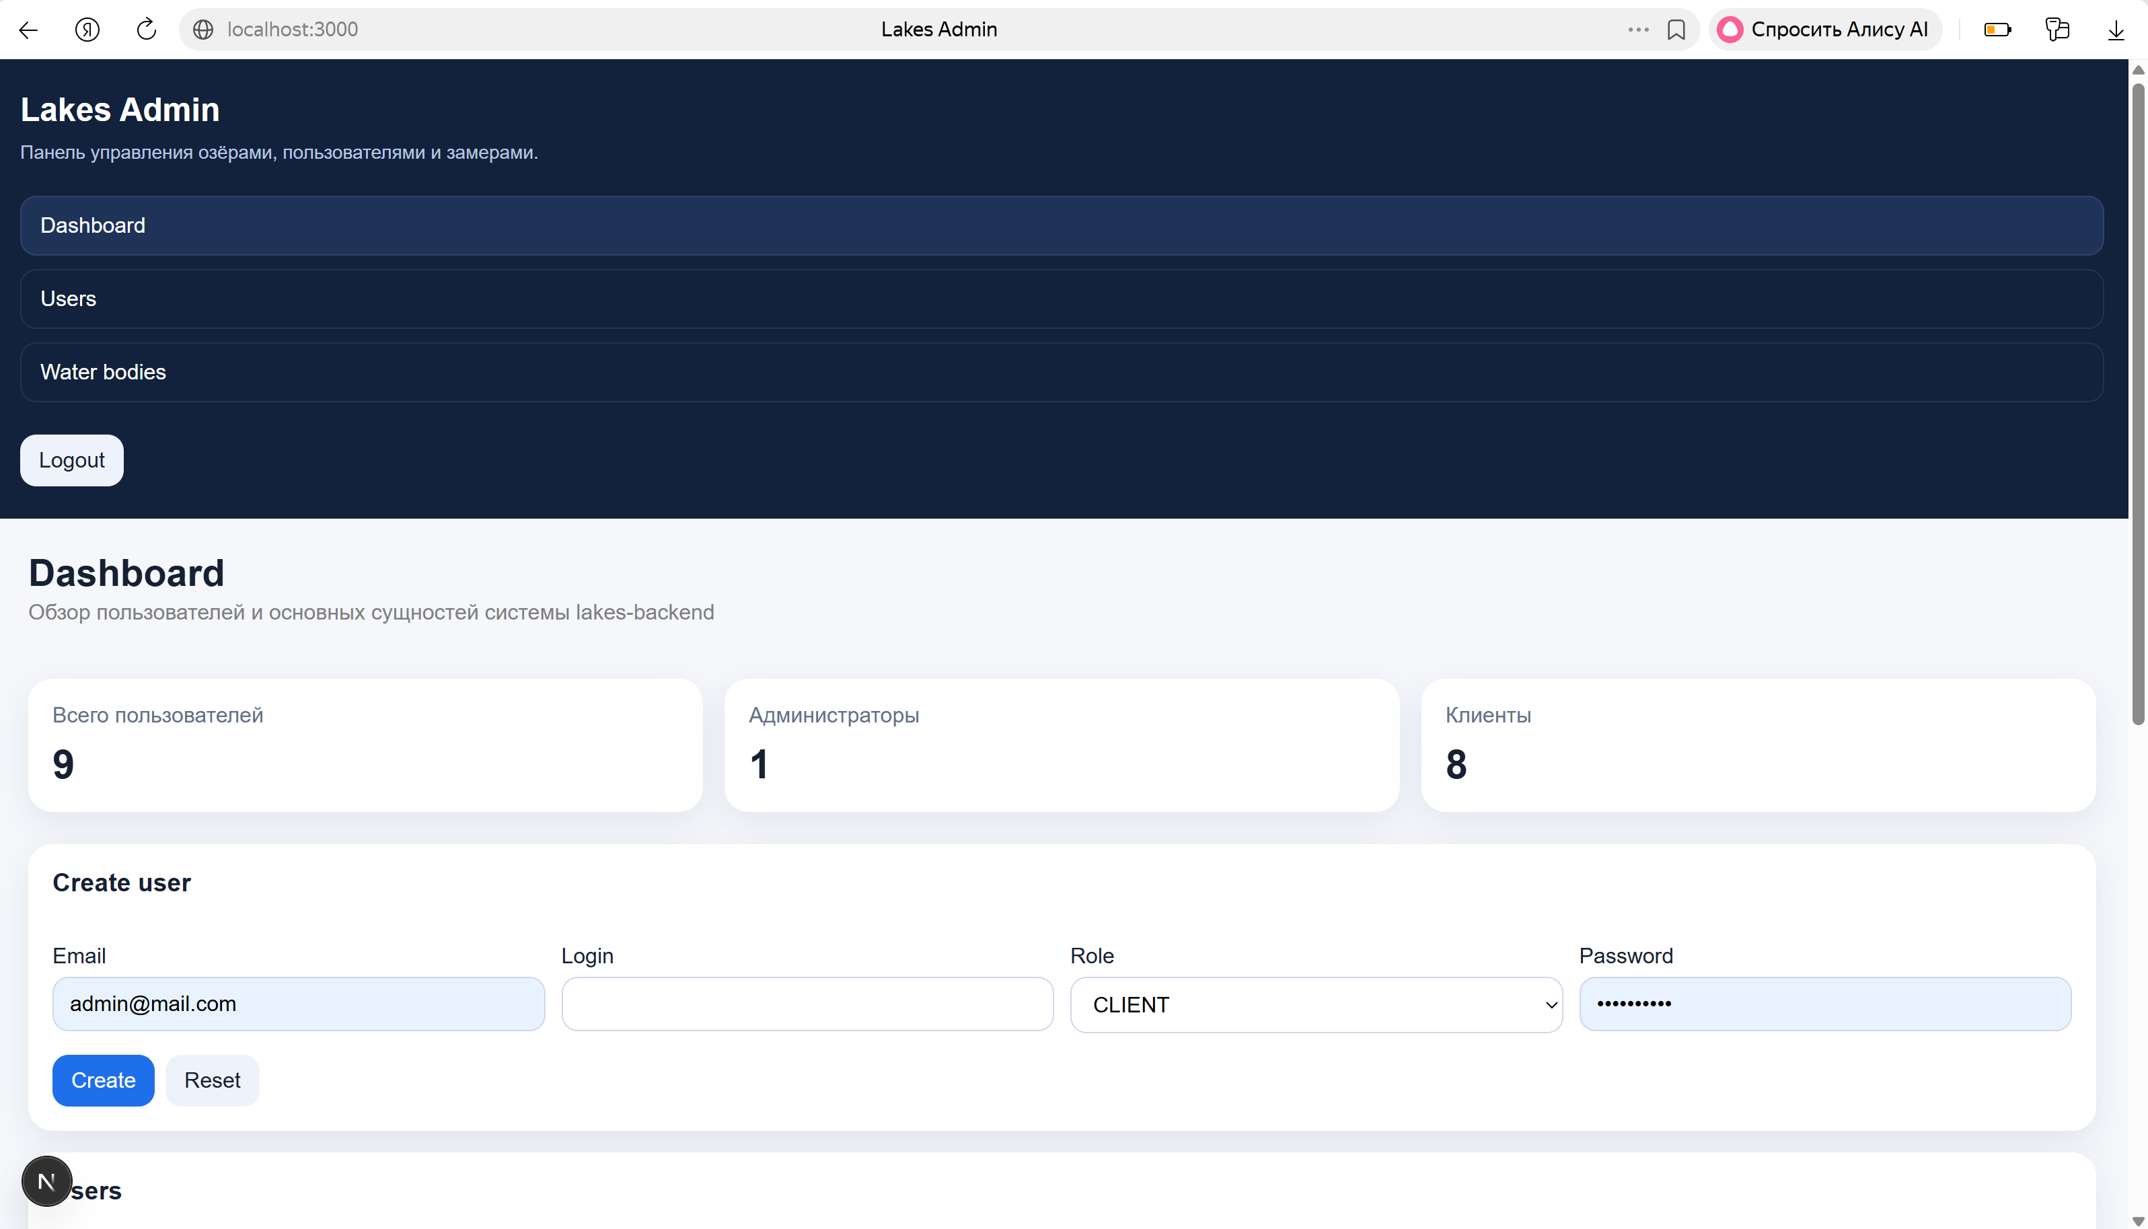

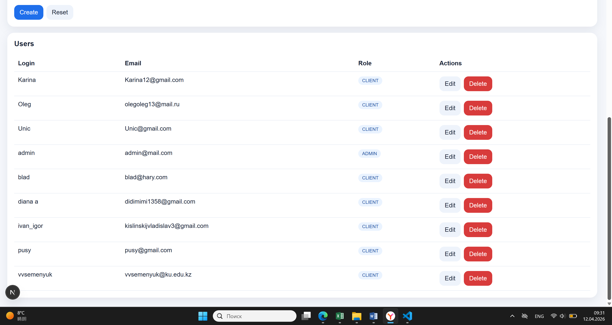

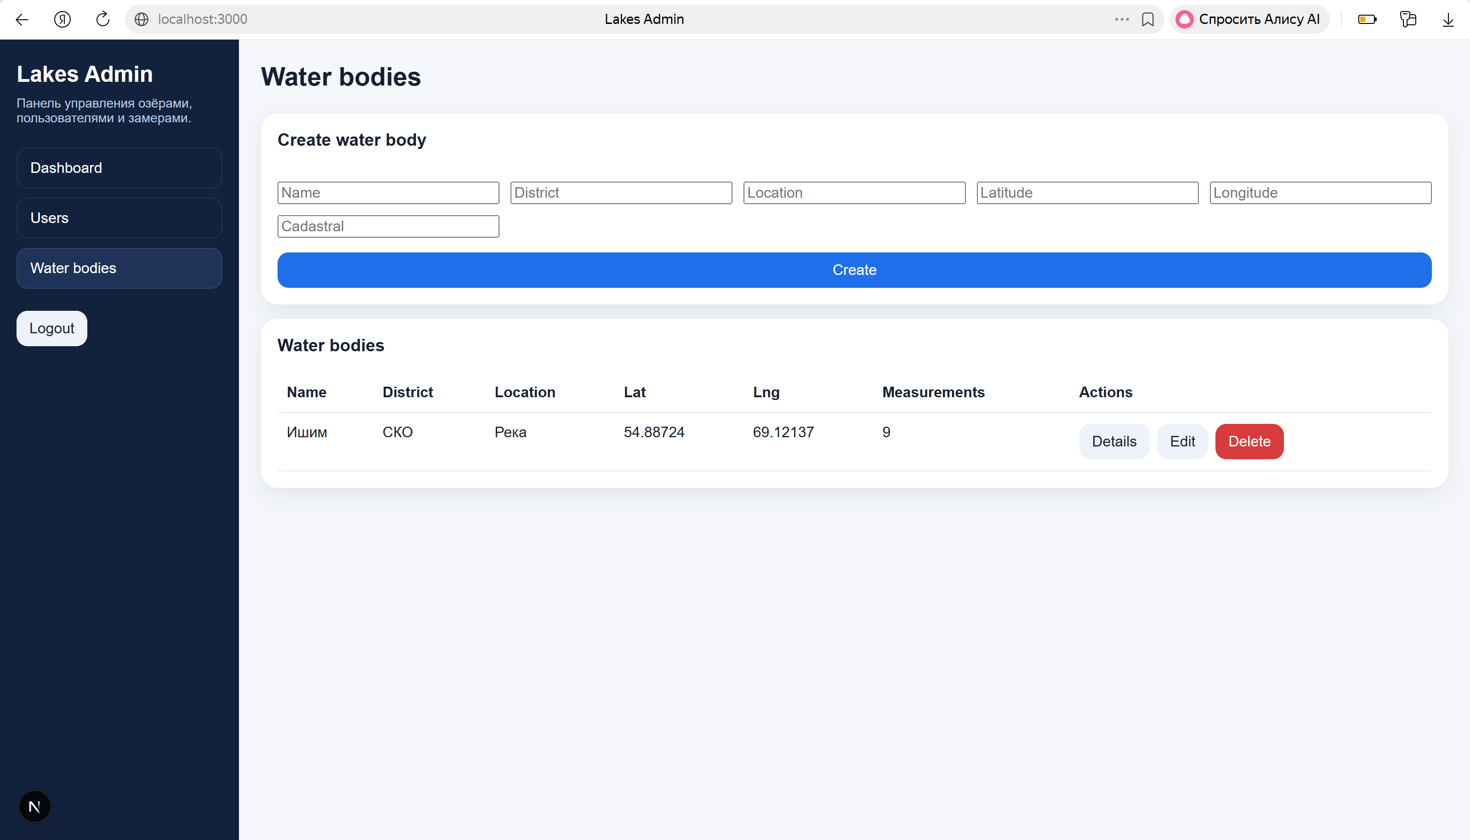
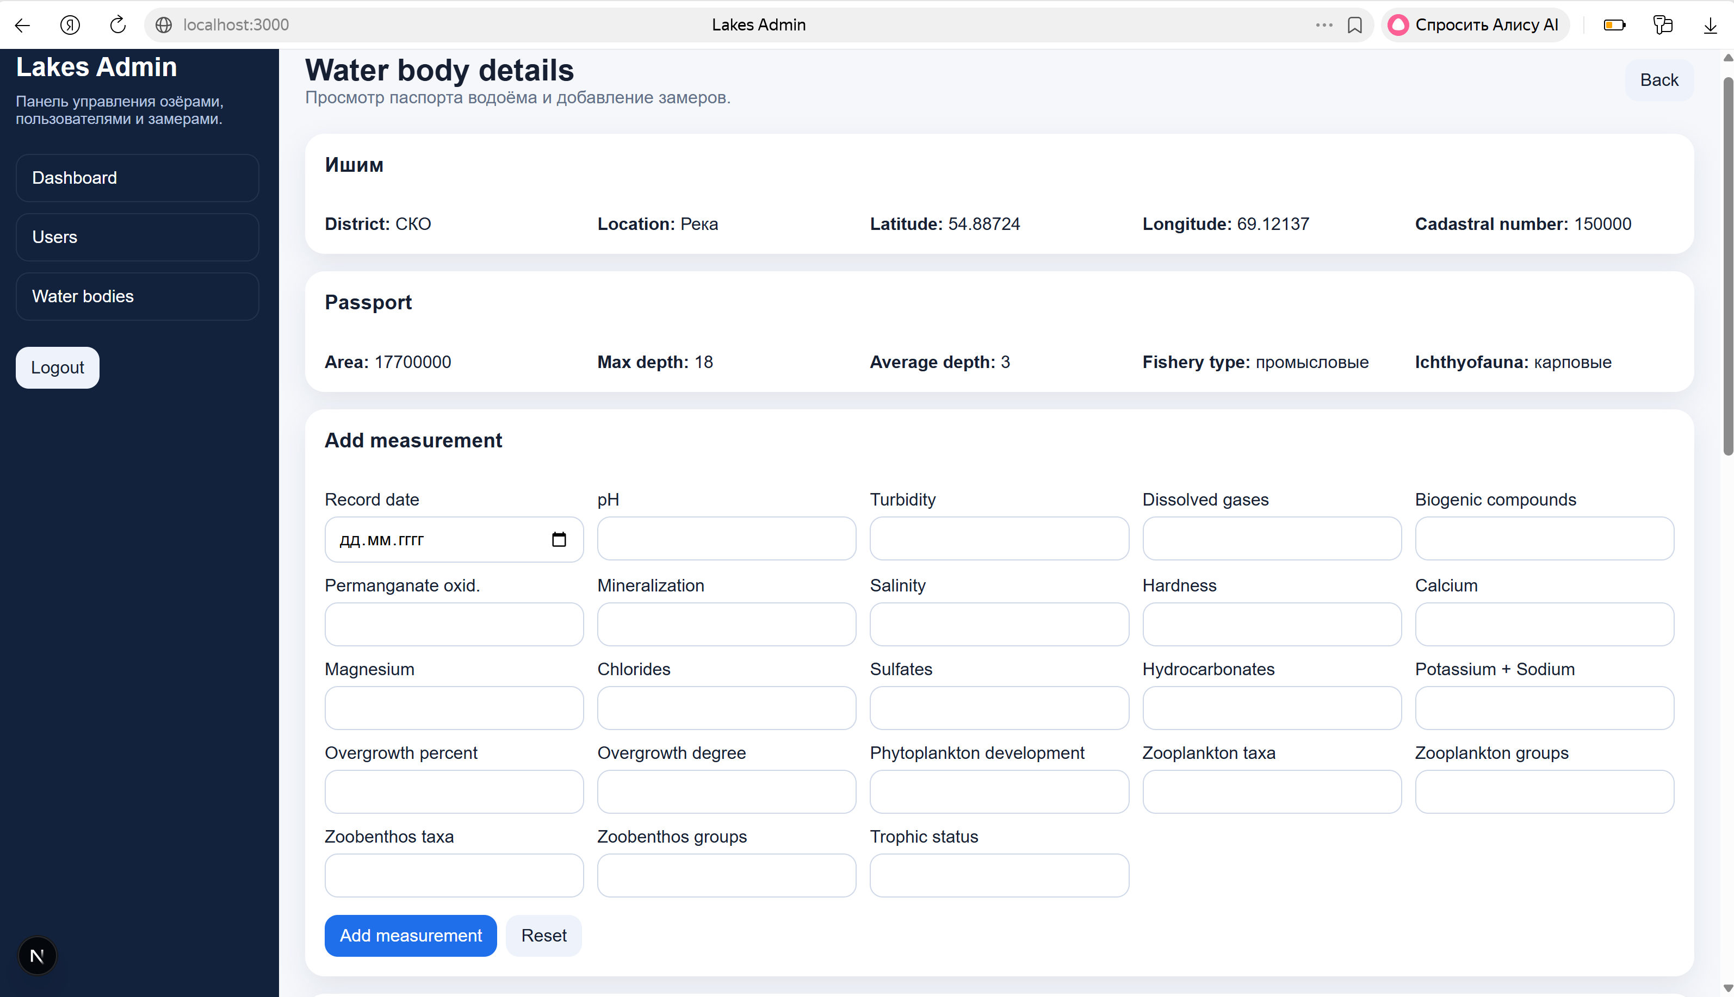
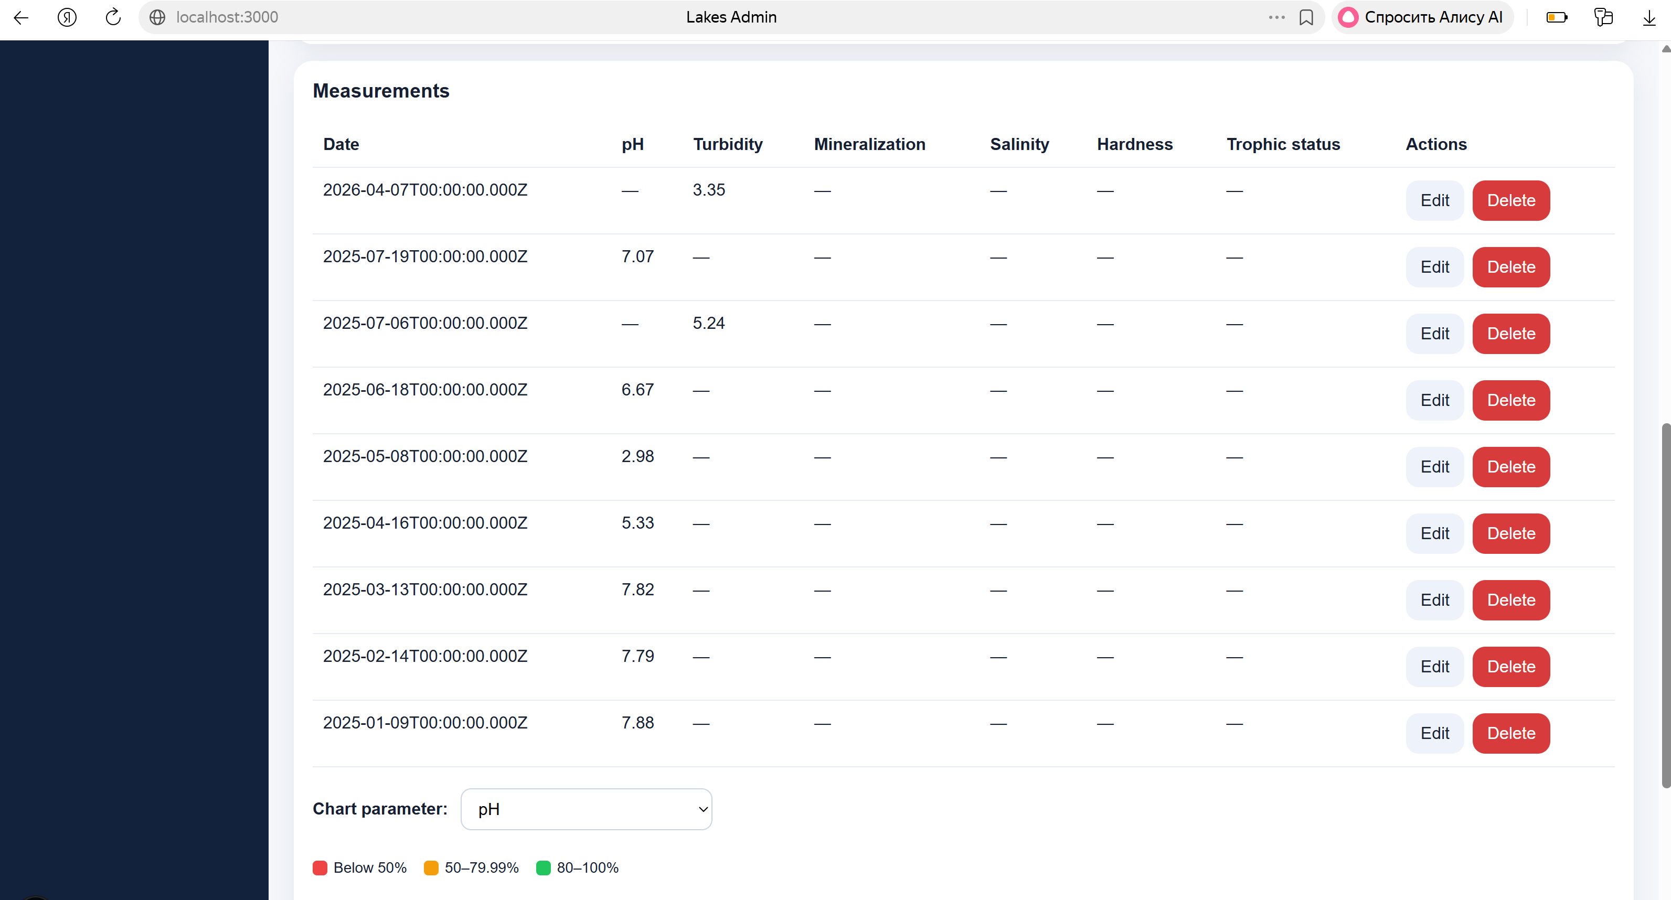
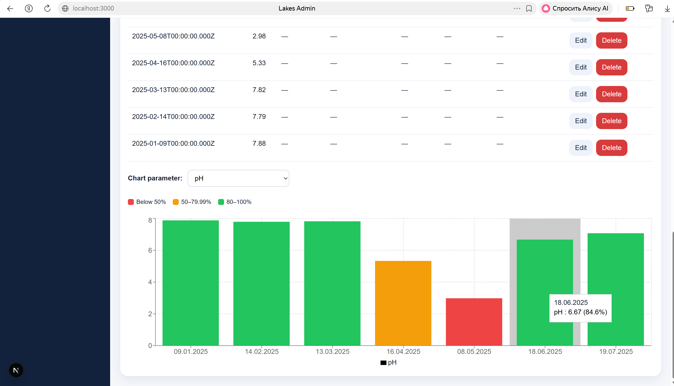

25. The next step is to deploy the project to Netlify. Before deploying the project, you need to create a new GitHub repository.

26. Don't rush to deploy the project. Be sure to check your Next JS version. It should be the latest one. If you don't have the current version, you can update it via Terminal using the command "npx fix-react2shell-next."
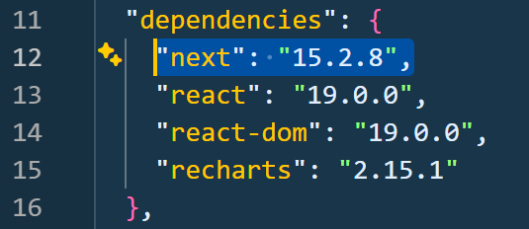

27. After this, deploy the project to Netlify.

28. Let's get started with the client side. Download the document from step 3 and unzip it. Install the project using the "npm install" command.

29. Let's look at the project structure.

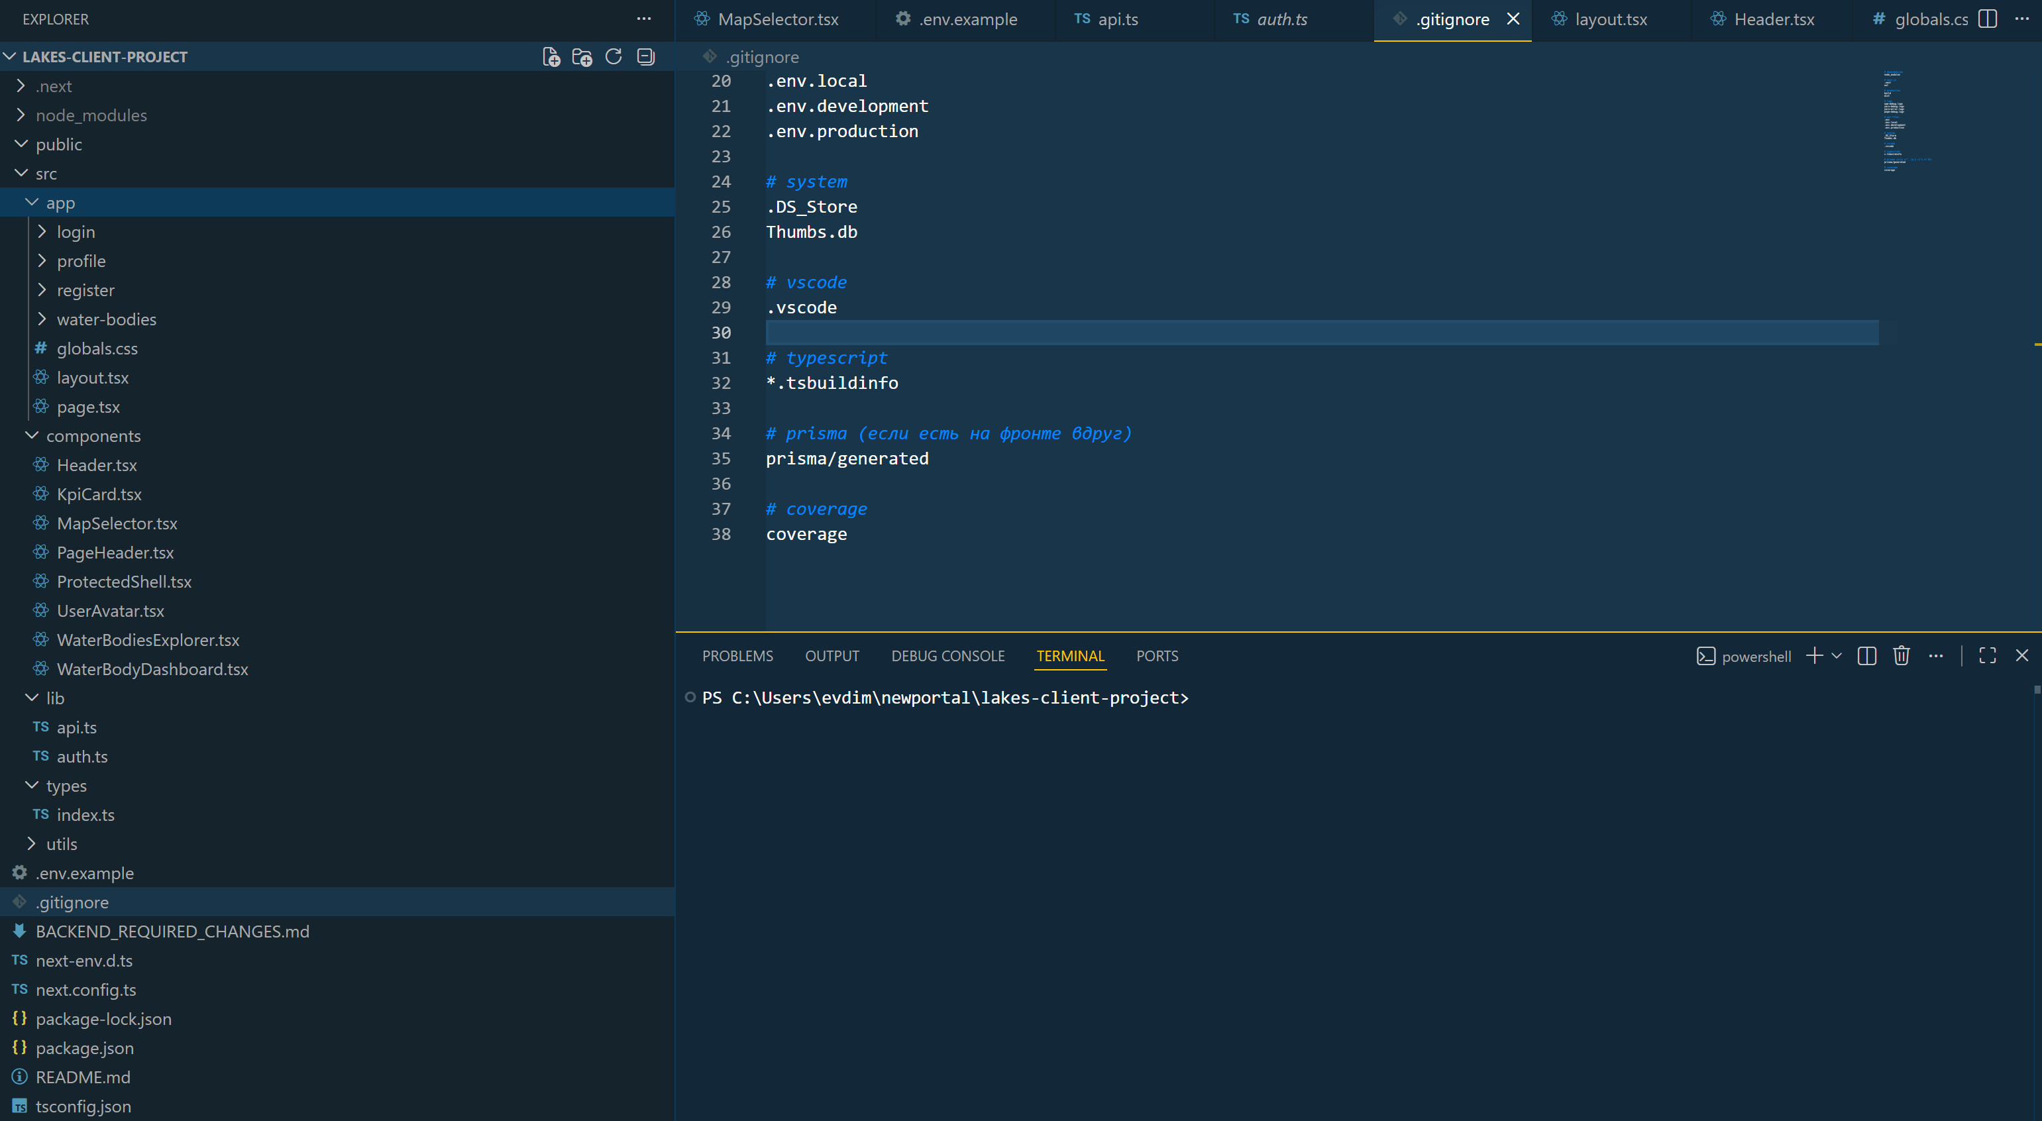

30. The src folder, which contains the main application logic, is located at the project root. The App Router structure (src/app) is used, with each folder corresponding to a route. The application's main page is implemented in the src/app/page.tsx file. It serves as the starting point and displays the client's main interface.

31. The src/app/layout.tsx file defines the global application structure. It includes styles (globals.css) and wraps all pages, ensuring a unified design. The src/app/login folder contains the user authorization page (page.tsx). It allows the user to log in and obtain access tokens.

32. The src/app/register folder contains the registration page (page.tsx), which allows the creation of a new user with the CLIENT role. The src/app/profile folder contains the personal account page (page.tsx). It displays user information, including their profile picture.

33. The src/app/water-bodies folder implements the water body management. The page.tsx file displays a list of all water bodies. A dynamic page (page.tsx) is implemented within the src/app/water-bodies/[id] folder, displaying detailed information about a specific water body.

34. The project uses the ProtectedShell.tsx component, which is responsible for checking authorization. If the user is not authorized, a redirect to the login page occurs.

35. The Header.tsx component implements the top navigation bar (instead of the sidebar). It contains the app title, page navigation, profile access, and a logout button.

36. The UserAvatar.tsx component is responsible for displaying the user avatar in the interface. The PageHeader.tsx component is used to display page titles and descriptions, ensuring a consistent style. The KpiCard.tsx component is designed to display statistical indicators (such as the number of bodies of water or other metrics). The MapSelector.tsx component implements map management and body of water selection. It can be used to display and interact with geographic data.

The WaterBodiesExplorer.tsx component is responsible for displaying a list of bodies of water in a browsing interface. It implements data output and interaction with list items. The WaterBodyDashboard.tsx component displays detailed information about the selected body of water, including: basic characteristics, passport, and measurement data.

37. The project uses the src/lib/api.ts file, which is responsible for interaction with the backend API. It implements the following methods: authorization, retrieving a list of reservoirs, retrieving a single reservoir, and retrieving measurements.

38. The src/lib/auth.ts file is responsible for token management. It implements: access token storage, refresh token storage, retrieving user data, and clearing data on logout.

39. The src/types folder describes all data types used in the project. This allows for strict control over the structure of objects retrieved from the server. The src/utils folder contains helper functions used in various parts of the application.

40. The client application implements a routing system that allows navigation from the list of water bodies to a specific water body, to the profile page, and to the authorization page. All data in the client is retrieved from the backend server via an API. The user cannot modify the data, only view it.

41. The project uses a modern approach to separating logic: pages (app) are responsible for routes, components (components) for the UI, lib for working with the API and authorization, and types for typing.

42. Let's demonstrate the project's appearance. After running the project with "npm run dev," you will see the following.
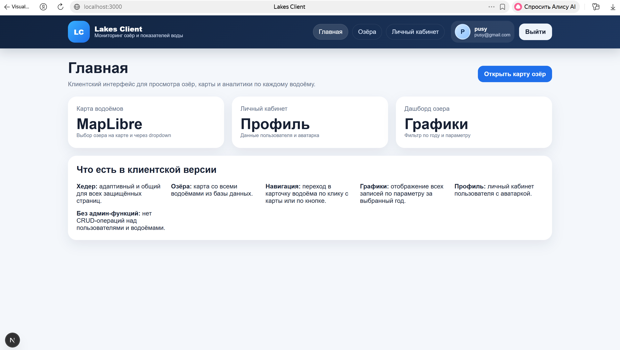
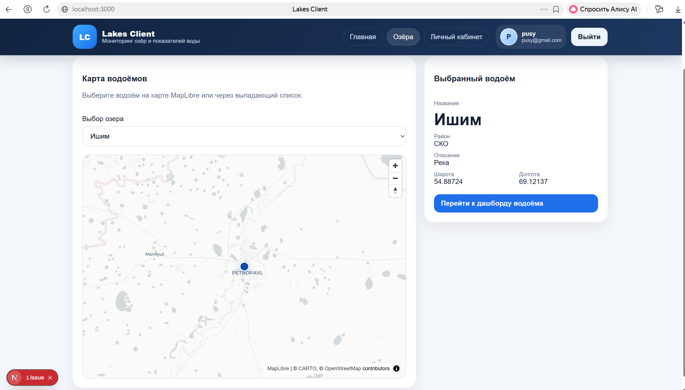
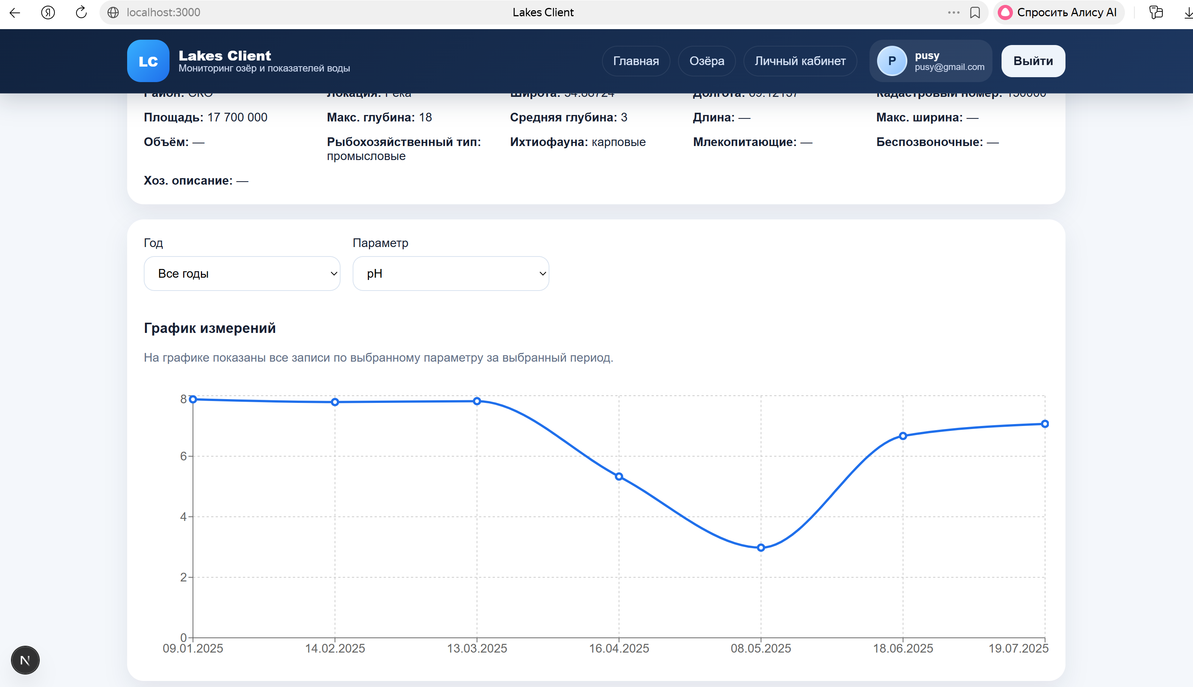

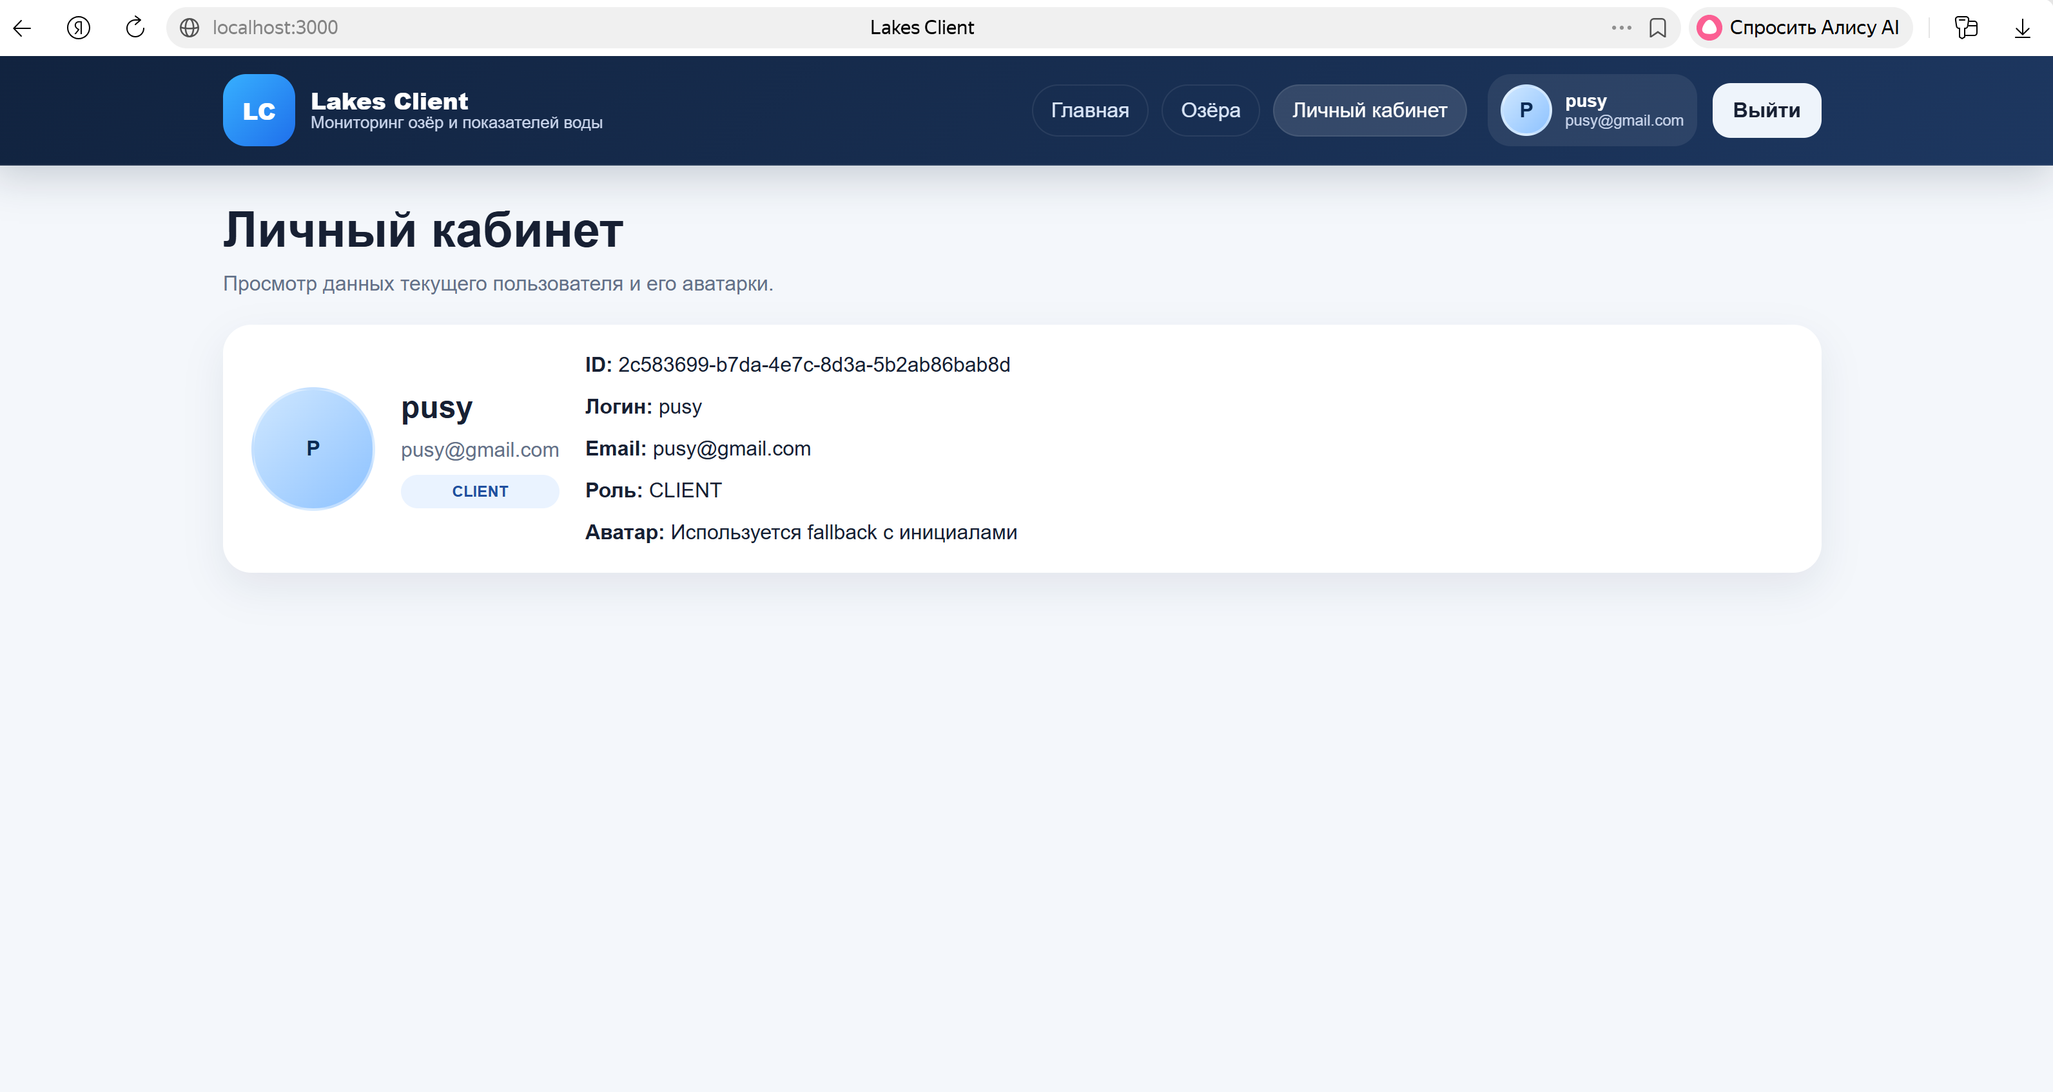

43. After customization, create a GitHub repository and render the project on Netlify.

44. Prepare the final report. The project should work and be viewable with Netlify and Render.

